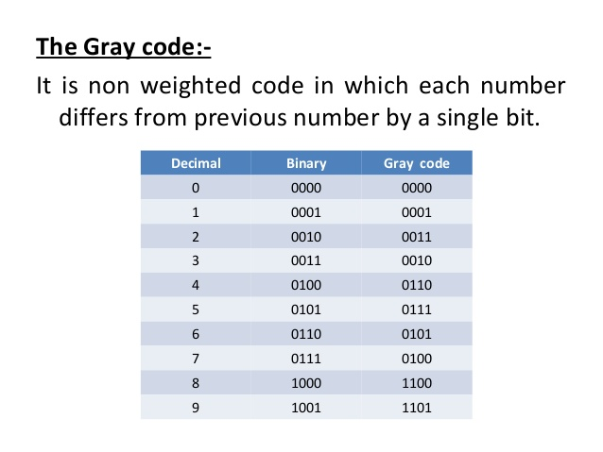

To make the Gray Code to binary code convertor and vice versa, we use K-Maps to obtain simplified circuit for finding each of the four output bits.

Excess-3 code is 3 added to the BCD code.

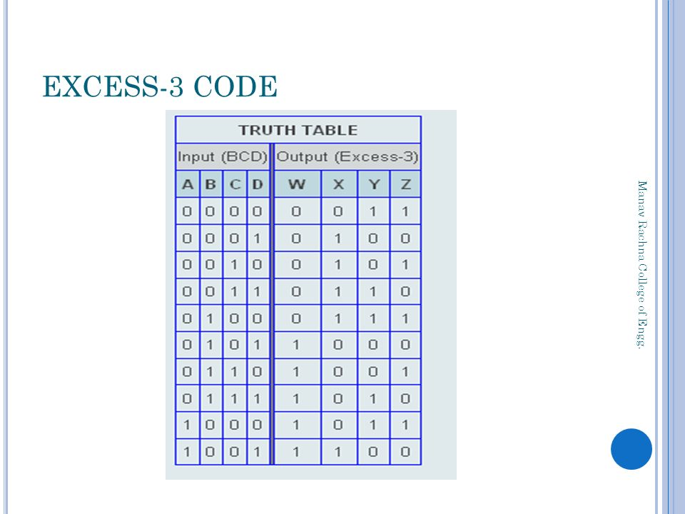

Just like Gray code to binary code convertor (and vice-versa), we use K-Maps to obtain simplified circuits for finding each of the four output bits in the BCD to Excess-3 convertor and vice-versa.